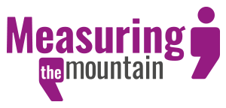

Measuring the Mountain was overseen by a Steering Group of people from across Wales who brought a broad range of experience, knowledge and expertise to the project. Between them, they represent a number of organisations from the third and public sectors, and they supported the project’s delivery, focus and development.

In 2019 / 2020 the Steering Group members were:

Neil Wooding | Ministry of Justice
Rachel Iredale | University of South Wales
Amber Powell  David Williams  Eve Parkinson  Faaiza Bashir  Mark Llewellyn (Observer)  Owen Evans  Rich Williams | Carers Wales  Greater Gwent Partnership  Monmouthshire County Council  Carers Trust Wales  University of South Wales  Children in Wales  Ministry of Justice
Roiyah Saltus  Ruth Dineen  Sara Woollatt  Sue Evans  Trevor Palmer  Vin West  Wayne Jepson  Katie Cooke | University of South Wales  Co-production Wales  Digital Communities Wales  Social Care Wales  GL100 ResponsABLE Assistance  Arfon Access Group  Public Health Wales  Measuring the Mountain

