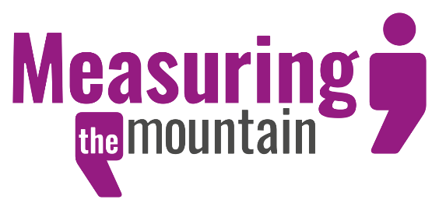
Measuring the Mountain – Understanding Experiences of Social Care in Wales
Measuring the Mountain is an all-Wales project evaluating the impact of the Social Services and Wellbeing (Wales) Act 2014. It is a collaboration between the public sector, third sector and, most importantly, the people who live here.
Funded by Welsh Government, the project will collect stories from people with recent experience of social care in order to build a picture of what social care feels like for the individuals involved.
The Measuring the Mountain team hope to work with organisations across Wales, both to let people know about the project and to help create a network of Listeners. Listeners will support people to share their stories and will play a vital role in ensuring that everyone who has a story is able to share it. Listeners can be staff or volunteers: volunteers will be able to join Spice’s Time Credits network and earn Time Credits for the stories they collect.
If you have a story to share, or if you know others who do, please get involved.
Measuring the Mountain will share their findings with Welsh Government, social care professionals, participants and, through their website and presentations, with people in Wales. In September, the project will host a Citizens’ Jury at the Liberty Stadium, Swansea, to look more closely at key issues that arise from the stories. Members of the public will examine a policy question, draw conclusions and present their recommendations.
Further information about all aspects of the project, including how to be a Listener, share a story or get involved in the Citizens’ Jury can be found on their website www.mtm.wales / www.mym.cymru
Or you can contact Katie, the project manager - kcooke@interlinkrct.org.uk / 07964 407 739

